Check it out!
Get to the point using excellent questions
Use problems to get an answer
Figure it out!



Be clear!
Know what you want to say, and say it!
Get your message across with clarity
Do it once, do it right!

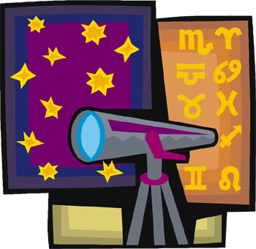

Open yourself to new opportunities
Lose yourself in a good book.
Walk a mile in someone’s shoes
Soak up learning like a sponge

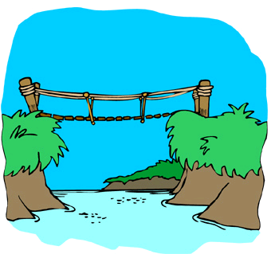
You know more than you think you do!
Link up with what you already know!
Don’t be afraid to use it to help you with your learning


Take your time!
Stop and think!
Think it through
Don’t panic
Slow and steady wins the race.

Learn to take a joke
Laugh a little
Try not to take things so seriously
Share a smile with a funny story.



Look at it a different way
Try another perspective or looking at it with different expectations


Check it again!
Always do your best
Set high standards for
yourself
GO FOR GOLD!

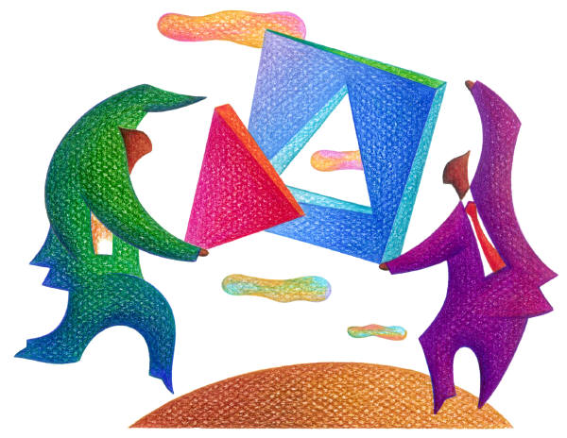

Have a go!
Trust yourself to get it right.
Try new things constantly.
Be strong and have courage.

Let’s work together!
United we stand, divided we fall!
Work as a team to complete the task.
Don’t be afraid to ask for help.
Reach out a hand to a class mate.



Stick to it!
Don’t give up.
Don’t let the side down.
Stay focused and on task.
Never give up.

Awesome!
The world is your playground and learning is the road that will take you there.
Be amazed.
Be thrilled.
Be passionate.

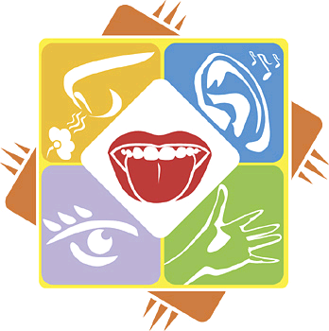

Immerse yourself!
Use your natural pathways! Pay attention to the world around you.
Gather data through all the senses: taste, touch, smell, hearing and sight

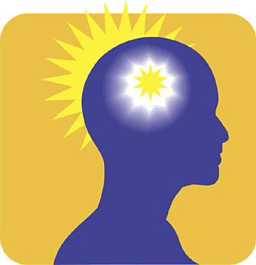

Try a different way!
Generate new and novel ideas.

Reflect.
Be aware of your own thoughts and strategies.

Be interested and caring.
Understand others.
Devote mental energy to another person's thoughts and ideas.
Make an effort to perceive another's point of view and emotions.

